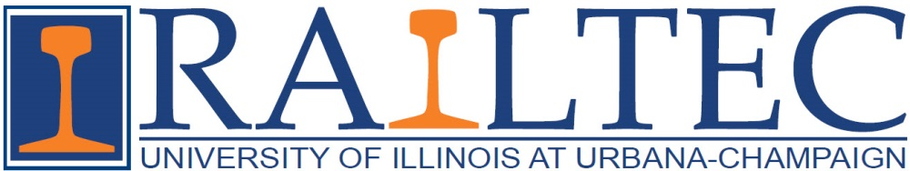

AREMA Educational Foundation - 2015 Scholarship Winners
Ivan Atanassov  University of Illinois at Urbana-Champaign  Communications & Signals Functional Group Scholarship  Samantha Chadwick  University of Illinois at Urbana-Champaign  Michael and Gina Garcia Rail Engineering Scholarship  Giovanni C. DiDomenico  University of Illinois at Urbana-Champaign  Committee 12 - Rail Transit Scholarship  Matthew J. Greve  University of Illinois at Urbana-Champaign  Committee 30 - Ties Scholarship  Phanuwat Kaewpanya  University of Illinois at Urbana-Champaign  REMSA Scholarship  Alexander H. Lovett  University of Illinois at Urbana-Champaign  Committee 24 - Education & Training Scholarship | Daniel R. Rivi  University of Illinois at Urbana-Champaign  Communications & Signals Functional Group Scholarship  Thomas A. Roadcap  University of Illinois at Urbana-Champaign  CSX Scholarship  Scott R. Schmidt  University of Illinois at Urbana-Champaign  Michael W. & Jean D. Franke Family Foundation Scholarship  Paul Shih  University of Illinois at Urbana-Champaign  Committee 5 - Track Scholarship  Kaijun Zhu  University of Illinois at Urbana-Champaign  Larry L. Etherton Scholarship

