Building better railroads: A sit down with RailTEC student Chen-Yu Lin
June 18, 2019 / 11:00am / By Alisa King

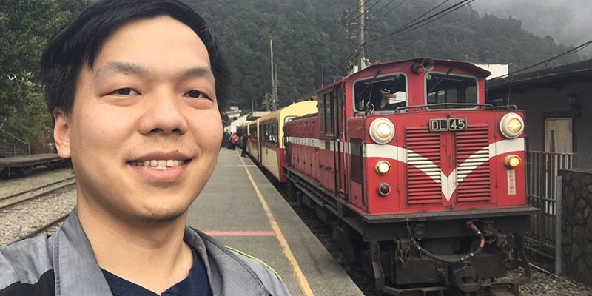
At the U of I, there are currently 14,344 graduate students enrolled as of Spring 2019. As a graduate student myself (Ph.D. candidate in microbiology), I can relate to the rollercoaster ride that many experience when pursuing a degree in higher education. One of those 14,344 graduate students striving to make a difference happens to be a friend of mine, Chen-Yu Lin. I first met Chen-Yu playing the popular mobile game Pokémon Go, tapping our phones furiously as we worked together to defeat a boss. Through the game, we developed a close friendship, and I began to respect and admire Chen-Yu for his dedication to school. I had an opportunity to sit down and chat with him, despite his crazy schedule.
Smile Politely: I know this is weird (since we know each other), but tell me a little about your background and how you came to the United States?
Chen-Yu Lin: So I’m originally from Taiwan and there, I studied civil engineering at the National Taiwan University or NTU. My parents and I used to take trains for fun when I was a kid, and even when we did not have time to take a train, they would take me to train stations to watch trains. Initially, I was not good at math and was not so confident about studying civil engineering until I met Professor Yung-Cheng Lai who initiated the railroad engineering program in NTU after getting his Ph.D. from the United States. He encouraged me to continue my study in civil engineering and combine my skills with what I like – pursue a Ph.D. in railroad engineering. My interest in trains and railroad was initially influenced by my parents, but it was really my professor who convinced me to bring it forward and to study abroad.
SP: For those aren’t familiar with the railroad program, can you describe the RailTEC program here at the U of I?
Lin: Yes so RailTEC stands for “Rail Transportation and Engineering Center.” U of I has a long history of railroad education. The program started 140 years ago, but there was no organized program until 1982. That year, the Association of American Railroads established an affiliated laboratory at the University. They also developed railroad courses and research. In 1998 the railroad engineering program officially formed when Professor Christopher Barkan was appointed as the director. In 2010 the program changed the name to RailTEC. RailTEC is a research program under transportation group under the department of civil and environmental engineering. You know that Talbot Lab on campus? It is named after Arthur N. Talbot who established the fundamental railroad track research. You know the W. William Hay plaque in Grainger? He wrote one of the most prestigious railroad engineering textbooks and taught and mentored two generations of railroad engineering professionals. He educated a lot of students at the U of I.
SP: Oh cool I didn’t know that. Which research group do you work in?
Lin: Yup. I work for Professor Christopher Barkan in RailTEC. After coming to the U.S., I realized that RailTEC is a friendly and motivating environment. The faculty are very supportive of the students, like encouraging us to travel to and present at domestic/international conferences, participate in industry coordinated projects, and social events like happy hour. Basically uniting students. It’s like my second family in the U.S. I decided to pursue a Ph.D.…the hole was there and I jumped to in to get the soul stone.
SP: Awesome Marvel reference! All right so coming back, what was your dissertation on?
Lin: So basically I wanted to address potential risks for shared use rail corridors where different types of trains (commuter, freight, and passenger trains) run on the same or adjacent tracks. Some of them have safety concerns like adjacent track accidents. An adjacent track accident is essentially talking about one train derailing and falling over on the adjacent track, where another train coming on the adjacent track can’t stop in time, so it collides with that train. I developed a risk-assessment model using stats and risk management to predict the probability of having such type of accidents and the consequences, identify possible risk mitigation strategies, and evaluate their effectiveness. Some risk mitigation measures include separating tracks further so that when train derails it won’t fall over to adjacent track, installing intrusion detection systems so that whenever an intrusion occurs a warning will be sent to engineers on the trains on adjacent tracks, and building barriers between tracks that will physically prevent trains from intruding.
SP: Are these accidents common?
Lin: It is not a common occurrence for adjacent track collisions. However, it is not uncommon that a train derails and fouls the right-of-way of an adjacent track, which poses a risk for trains on the adjacent track to collide with the derailing train. With recent expansion of more frequent and higher speed passenger trains services, people expect more interactions of trains on multiple tracks. This was not the case in the United States for a while until recently.
SP: Ah I see. Well, since we are talking about trains, I have to ask, what was your favorite train ride so far?
Lin: Oh that’s hard haha. I can’t pick my favorite.
SP: Okay, how about top 3 then?
Lin: Okay I can do that. When I was in Taiwan, I used to take the Ordinary Train and we dubbed it “blue-skinned” (because of the blue color) train that goes through southern coast of Taiwan, very scenic with mountains and the ocean, bridges and tunnels. You can also open windows to enjoy the breeze. I love listening to the clicking sound of the train. Not a luxurious train, but very relaxing.
In the U.S., the train I like the most is the California Zephyr that goes from Chicago to Emeryville, California. It’s a two-day trip that goes across a lot of states. You get to see all types of terrain and scenery like prairie views in Illinois, Iowa, and Nebraska, mountains and snow in Denver, and curvy tracks. In Utah you get to see red rock and you know, highland desert territory. And then you see more desert in Nevada. And then when you go to California, you see greenery and bushes. You will enjoy the food because you can get steak and seafood platters. They have an observation car where the chairs are facing towards the windows, which are bigger than normal. It’s a very relaxing train ride.
My 3rd favorite is the train in South Africa called the Shosholoza Meyl. I took this train from Cape Town to Johannesburg. It’s a 24-hour train and it’s very impressive because first off, you can open the windows and you go from advanced city landscape into more rural areas, and then beautiful mountains along the river. Then, you get to another farmland area and see nice sunsets and sunrises. When you approach Johannesburg, you get to see the city views. This is also a very scenic train ride. South Africa was the least expected country I thought I’d go to, but it turned out to be the first country I visited in the Southern Hemisphere.
SP: I’m surprised you didn’t have any trains from Japan on that list.
Lin: The whole Japanese Railway system is collectively impressive so it’s hard to choose. Maybe I’m so impressed because I went there many times (laugh). If we’re talking system, Japan is number one no doubt. Japan is on it’s own level at the very top. You can’t beat the speed, comfort, and service.
There are some popular excursion trains in Kyushu area. Most of them are fairly affordable but there are also expensive (and luxurious ones) such as dessert trains (the Aru Ressha Sweet Train) that cost $250 USD. There is also a jazz music style themed train. On the train, it plays the signature jazz song “A Train” and you can grab a beer at the bar on the train.
SP: I will definitely keep those trains in mind. Okay so now that you have your doctorate, what's next for you?
Lin: My long-term goal is teaching and eventually I would like to become a professor, but before that I would like to get industry experience first. I am going to be a Postdoctoral Research Associate in RailTEC to conduct more research, since they have been so supportive to me. Eventually, I want to go to the rail industry to get more experience with railroad companies or consulting firms.
SP: What do you do outside of research or when you’re not thinking about trains to relax and/or de-stress?
Lin: Well I play video games. As you know, I play Pokémon Go. And I like singing so I like to go to karaoke with friends. I also play guitar sometimes and play volleyball/exercise so it’s kind of a way to relieve stress. I also go train watching so it’s kind of like research so I don’t know if it counts? But watching trains is also a leisure of mine.
SP: Where do you go to train watch here in town?
Lin: There’s a Champaign yard next to the mall in town that I go to, or nearby places to watch trains in the yard. Usually when I go, I go out of town to nearby places like Tolono, Tuscola, and Decatur.
SP: Finally, is there anything you wish you knew before going into grad school that you’d like to tell future engineers?
Lin: I would say set a long-term goal, and execute it by achieving short to midterm target goals. Train yourself for good time management and problem solving skills. If I could restart again, I would train myself more in those areas. Civil is a very practical field so try your best to get an internship in the industry and get hands-on experience to learn the current demands in civil engineering. Pretty much everything you do or encounter in your daily life is somewhat related to civil engineering. At the university, enjoy the time with your colleagues and don’t bury yourself in your work and have a work-life balance. But I think time management and problem solving are the most important things. And even today I’m still learning. You never stop learning so learn what you can while you still can, and never stop thinking about making the world better.

